Lab 10 – Exercise 1: File Writing and Reading
Aim
To develop a Java program that accepts five lines of text from the user, saves them to a file, and reads the saved contents back.
Source Code
Main.java

package lab10filehandling;

import java.io.BufferedReader;
import java.io.BufferedWriter;
import java.io.FileReader;
import java.io.FileWriter;
import java.io.IOException;
import java.util.Scanner;

public class Main {

public static void main(String[] args) {

Scanner input = new Scanner(System.in);
String fileName = "userlines.txt";

try {
// Write five lines to the file
BufferedWriter writer =
new BufferedWriter(new FileWriter(fileName));

System.out.println("Enter five lines of text:");

for (int i = 1; i <= 5; i++) {
System.out.print("Line " + i + ": ");
String line = input.nextLine();
writer.write(line);
writer.newLine();
}

writer.close();

System.out.println("\nLines saved successfully.");

// Read and display the file contents
BufferedReader reader =
new BufferedReader(new FileReader(fileName));

System.out.println("\nContents of the file:");

String line;
while ((line = reader.readLine()) != null) {
System.out.println(line);
}

reader.close();

} catch (IOException e) {
System.out.println("File error: " + e.getMessage());
}

input.close();
}
}
Explanation
The program uses a Scanner to collect five lines from the user. A BufferedWriter writes each line to a text file named userlines.txt. After writing the data, the program closes the writer and opens the file using a BufferedReader.
The readLine() method reads the file one line at a time until the end of the file is reached. An IOException handler manages possible file-related errors.
Output
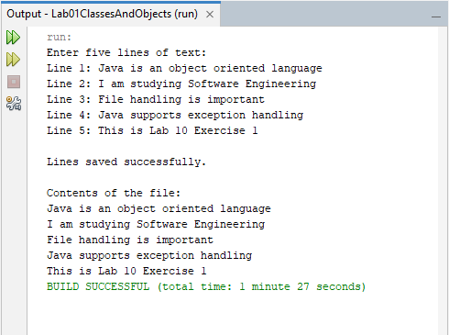
The program successfully saves five user-entered lines to userlines.txt and displays the same lines on the screen.
Conclusion
The exercise demonstrated how Java can write data to a text file and read it back. It also introduced buffered input/output classes and exception handling during file operations.

Exercise 2: Predicate and removeIf()
Aim
To use a Predicate and the removeIf() method to remove all even numbers from a list of integers.
Source Code
Main.java

package lab10filehandling;

import java.util.ArrayList;
import java.util.Arrays;
import java.util.List;
import java.util.function.Predicate;

public class Main {

public static void main(String[] args) {

List<Integer> numbers = new ArrayList<>(
Arrays.asList(10, 15, 22, 7, 8, 31, 44, 19, 6, 13)
);

System.out.println("Original list: " + numbers);

// Predicate identifies even numbers
Predicate<Integer> isEven = number -> number % 2 == 0;

// Remove every number that satisfies the predicate
numbers.removeIf(isEven);

System.out.println("List after removing even numbers: " + numbers);
}
}
Explanation
The program creates an ArrayList containing ten integers. A Predicate<Integer> named isEven uses a lambda expression to determine whether a number is divisible by two. The removeIf() method then removes all numbers that satisfy this condition, leaving only odd numbers in the list.
Output
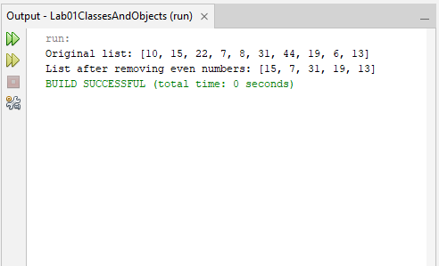
Conclusion
The exercise demonstrated how predicates and lambda expressions can define conditions concisely. It also showed how removeIf() can simplify the removal of elements that meet a specified condition.

Exercise 3: Counting Lines, Words and Characters
Aim
To develop a Java program that reads a text file and calculates the number of lines, words, and characters contained in it.
Source Code
Main.java

package lab10filehandling;

import java.io.BufferedReader;
import java.io.FileReader;
import java.io.IOException;

public class Main {

public static void main(String[] args) {

String fileName = "sample.txt";

int lines = 0;
int words = 0;
int characters = 0;

try (BufferedReader reader =
new BufferedReader(new FileReader(fileName))) {

String line;

while ((line = reader.readLine()) != null) {
lines++;

// Count characters, excluding line separators
characters += line.length();

// Count words separated by whitespace
String trimmedLine = line.trim();

if (!trimmedLine.isEmpty()) {
words += trimmedLine.split("\\s+").length;
}
}

System.out.println("Number of lines: " + lines);
System.out.println("Number of words: " + words);
System.out.println("Number of characters: " + characters);

} catch (IOException e) {
System.out.println("File error: " + e.getMessage());
}
}
}
Sample.txt
Java is easy to learn.
File handling is useful.
Streams process data.
Explanation
The program reads sample.txt using a BufferedReader. It processes the file line by line, incrementing the line counter for each line read. The character counter uses the length of each line, while the word counter splits non-empty lines using whitespace as the separator.
The program uses try-with-resources to close the file automatically and catches IOException to handle file-related errors.
Output
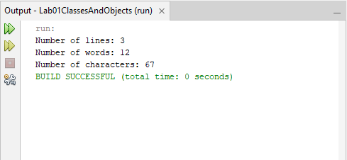
Conclusion
The exercise demonstrated how Java file-reading methods and string operations can be combined to analyse text files. It also introduced try-with-resources for reliable resource management.

Exercise 4: Student Records and Streams
Aim
To use Java records and streams to calculate the class average and display the names of students scoring above average in alphabetical order.
Source Code
Main.java

package lab10filehandling;

import java.util.Arrays;
import java.util.List;

record Student(String name, int marks) {}

public class Main {
public static void main(String[] args) {

List<Student> students = Arrays.asList(
new Student("Tendai", 78),
new Student("Brian", 65),
new Student("Angela", 92),
new Student("Farai", 74),
new Student("Grace", 81)
);

double average = students.stream()
.mapToInt(Student::marks)
.average()
.orElse(0);

System.out.println("Class average: " + average);
System.out.println("Students scoring above average:");

students.stream()
.filter(student -> student.marks() > average)
.map(Student::name)
.sorted()
.forEach(System.out::println);
}
}
Explanation
A Student record was created to store each student's name and marks. A list of students was processed using streams to calculate the average mark. The filter() method selected students who scored above the average, while map() extracted their names. The sorted() method arranged the names alphabetically, and forEach() displayed them.
Output
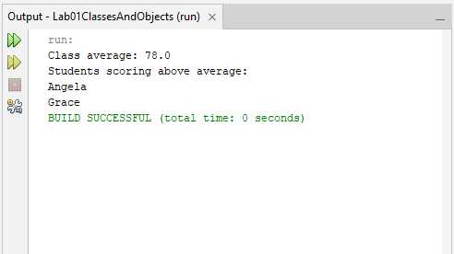
Conclusion
The exercise demonstrated how Java records and streams can simplify data processing, filtering, and sorting.
Exercise 5: Grouping Learners by Grade Band
Aim
To read learner information from a CSV file, group learners into grade bands using Java streams and Collectors.groupingBy(), and generate a separate report file for each grade band.
Source Code
Main.java

package lab10filehandling;

import java.io.BufferedReader;
import java.io.BufferedWriter;
import java.io.FileReader;
import java.io.FileWriter;
import java.io.IOException;
import java.util.ArrayList;
import java.util.List;
import java.util.Map;
import java.util.stream.Collectors;

record Learner(String name, int marks) {
String gradeBand() {
if (marks >= 80) {
return "A";
} else if (marks >= 60) {
return "B";
} else {
return "C";
}
}
}

public class Main {

public static void main(String[] args) {

List<Learner> learners = new ArrayList<>();

// Read learners from the CSV file
try (BufferedReader reader =
new BufferedReader(new FileReader("learners.csv"))) {

String line;
reader.readLine(); // Skip the CSV header

while ((line = reader.readLine()) != null) {
String[] data = line.split(",");

String name = data[0].trim();
int marks = Integer.parseInt(data[1].trim());

learners.add(new Learner(name, marks));
}

} catch (IOException | NumberFormatException e) {
System.out.println("Error reading learners.csv: "
+ e.getMessage());
return;
}

// Group learners by grade band
Map<String, List<Learner>> groupedLearners =
learners.stream().collect(
Collectors.groupingBy(Learner::gradeBand));

// Create one report file for each grade band
String[] gradeBands = {"A", "B", "C"};

for (String grade : gradeBands) {
String fileName = "report_" + grade + ".txt";

try (BufferedWriter writer =
new BufferedWriter(new FileWriter(fileName))) {

writer.write("GRADE " + grade + " REPORT");
writer.newLine();
writer.write("================");
writer.newLine();

List<Learner> group = groupedLearners.getOrDefault(
grade, new ArrayList<>());

for (Learner learner : group) {
writer.write(learner.name() + " - "
+ learner.marks());
writer.newLine();
}

System.out.println(fileName
+ " created successfully.");

} catch (IOException e) {
System.out.println("Error writing " + fileName
+ ": " + e.getMessage());
}
}
}
}
Learners.csv
name,marks
Tendai,85
Angela,92
Brian,67
Grace,78
Farai,45
Rudo,54
Michael,81
Peter,60
Explanation
A CSV file named learners.csv was created to store learner names and marks. The program read the file and converted each row into a Learner record. A method assigned each learner to grade A, B or C based on their marks. Java streams and Collectors.groupingBy() were then used to group the learners by grade band. Finally, BufferedWriter created three report files: report_A.txt, report_B.txt and report_C.txt.
Output
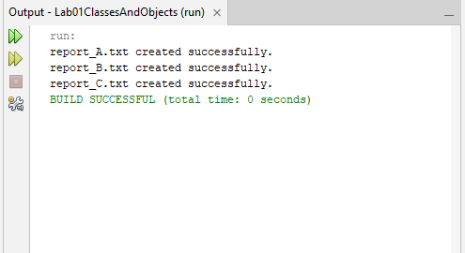
The program successfully created the three report files, each containing the learners belonging to its grade band.
Conclusion
The exercise demonstrated file handling, Java records, streams, grouping with collectors, and writing processed data to separate files.

